Mahara Tip Sheet
Help Desk: 704-687-5500
help@uncc.edu

Logging In
- Access through Canvas in the left hand link “Mahara” in the course navigation
- You are now on the home screen/dashboard
Menu Bar
- You will access all categories through this button on the upper right:

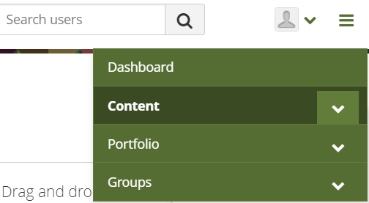
Adding Content
- Click the green Menu Bar
- Click the drop down for “Content”
- Click “Files”
- Drag and drop files OR click “Choose Files”
to find your files

Making a Page or Collection
*Pages are individual spaces, Collections are pages grouped together
- Click the green Menu Bar
- Click the drop down for “Portfolio”
- Click “Pages and collections”
- To add a new page or collection, click the “+ Add” button
- Select a page or collection
  - Page
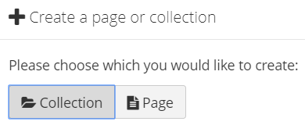
    - Enter your title and description
    - Choose your layout
    - “Save”. You are now in edit mode
  - Collection
    - Enter your title and description
    - Click “Next: Edit collection pages”
    - Select pages and mark “Done”
*You can change any of these features at a later time

Organizing/Editing the Page
- Click the gray “Edit” button
- On the left hand side, find the type of
artifact you wish to add.
- Drag and drop onto canvas, or click directly
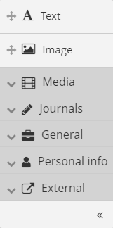
on the icon to select a space.
- Fill in prompted selections.
- Click “Display Page” at the bottom to save
and view

* You can move the item again at any time

Sharing Your Work
- Click the green Menu Bar
- Click the drop down for “Portfolio”
- Click “Shared by me”
  - Secret URLs – share to an Assignment or with others off campus
    - Click the globe icon next to page/collection desired
    - Click “+ New secret URL”
    - Copy/Paste this URL
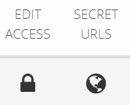
  - Edit Access – share with others on campus
    - Click the lock icon next to page/collection desired
    - Choose the various parameters
    - Click “Save”

TIPS

- You can edit any portfolio at any time.
- Your portfolio is invisible until shared.
- The URL at the top of the page will not work if copy and pasted. You must use a secret URL.
- The secret URL is what you turn into Canvas Assignments
- Pages can only live in one collection at a time.

